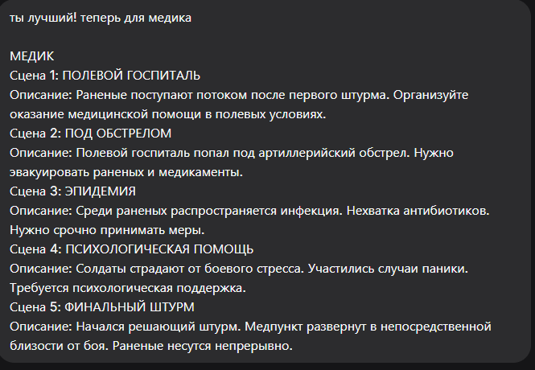
Безусловно, вот промты для сцен медика, выдержанные в том же стиле.

Сцена 1: ПОЛЕВОЙ ГОСПИТАЛЬ
Промт:
masterpiece, best quality, 8k, photorealistic, field hospital in an abandoned warehouse at night. Rows of wounded soldiers on stretchers, their faces and bodies obscured by blankets or turned away. The silhouettes of medics in white armbands with red crosses moving between the cots. Medical equipment, IV drips, dim electric lighting. No visible human features, only silhouettes and obscured forms.
Negative Prompt:
deformed, blurry, bad anatomy, disfigured, poorly drawn face, mutation, mutated, extra limb, ugly, poorly drawn hands, missing limb, blurry, floating limbs, disconnected limbs, malformed hands, long neck, human face, detailed face, fingers, blood, gore

Сцена 2: ПОД ОГНЕМ
Промт:
masterpiece, best quality, 8k, photorealistic, chaotic evacuation of a field hospital under artillery fire. The silhouettes of medics carrying stretchers with wounded through a smoky, cratered landscape at dusk. Explosions in the background illuminating the scene. Blurred motion, sense of urgency. No people details, only dark silhouettes against the fire.
Negative Prompt:
deformed, blurry, bad anatomy, disfigured, poorly drawn face, mutation, mutated, extra limb, ugly, poorly drawn hands, missing limb, blurry, floating limbs, disconnected limbs, malformed hands, long neck, human face, detailed face, fingers, calm, peaceful

Сцена 3: ЭПИДЕМИЯ
Промт:
masterpiece, best quality, 8k, photorealistic, tense scene inside a field tent, medical staff in protective masks and gloves (obscured). A medic's silhouette checking a patient's chart, empty boxes of antibiotics on a table. Atmosphere of exhaustion and urgency, focused on objects and obscured forms. No visible faces or skin.
Negative Prompt:
deformed, blurry, bad anatomy, disfigured, poorly drawn face, mutation, mutated, extra limb, ugly, poorly drawn hands, missing limb, blurry, floating limbs, disconnected limbs, malformed hands, long neck, human face, detailed face, fingers, smiling, healthy

Сцена 4: ПСИХОЛОГИЧЕСКАЯ ПОМОЩЬ
Промт:
masterpiece, best quality, 8k, photorealistic, intimate scene in a quiet corner of a bunker. The silhouettes of a soldier (head in hands) and a medic sitting beside him, offering a cup of tea. Dim light from a single lantern, creating deep shadows that hide their features. Atmosphere of solace and support.
Negative Prompt:
deformed, blurry, bad anatomy, disfigured, poorly drawn face, mutation, mutated, extra limb, ugly, poorly drawn hands, missing limb, blurry, floating limbs, disconnected limbs, malformed hands, long neck, human face, detailed face, fingers, yelling, violence

Сцена 5: ФИНАЛЬНЫЙ ШТУРМ
Промт:
masterpiece, best quality, 8k, photorealistic, advanced medical aid post during the final assault. A makeshift bunker close to the frontline, dust falling from the ceiling with each nearby explosion. The blurred silhouettes of medics working tirelessly over a wounded soldier on a table. The room is filled with smoke and tension. No visible human details, only shapes in motion.
Negative Prompt:
deformed, blurry, bad anatomy, disfigured, poorly drawn face, mutation, mutated, extra limb, ugly, poorly drawn hands, missing limb, blurry, floating limbs, disconnected limbs, malformed hands, long neck, human face, detailed face, fingers, clean, sterile room

